Step:1 Download autoit from the below

Link: <https://www.autoitscript.com/site/autoit/downloads/>

Open a website: <https://www.shine.com/registration/>

Goto windows search bar and search for Autoit

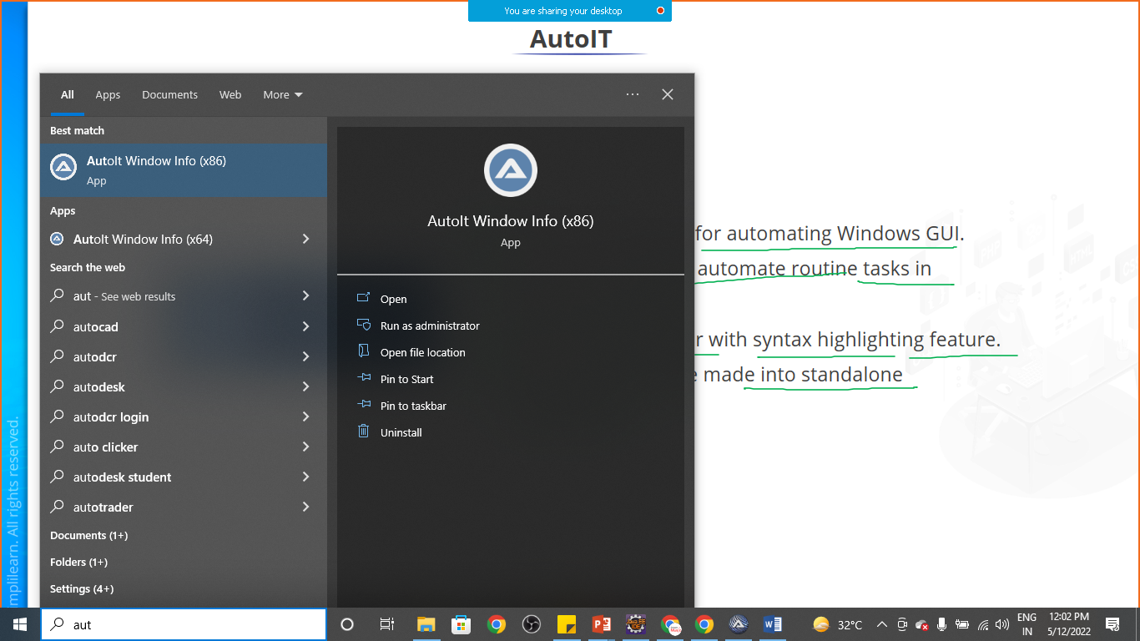

Select Autoit and open

Click on upload resume button of registration page

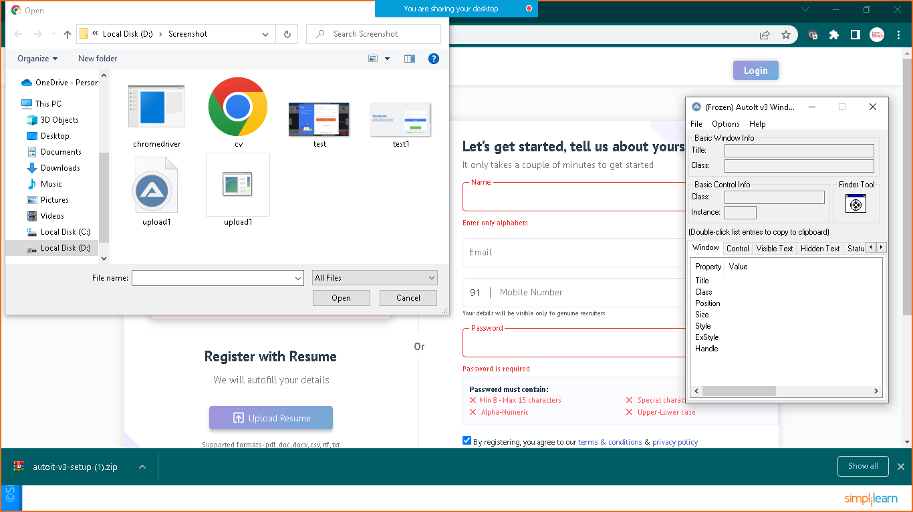

Now drag and drop finder tool to **Filename Text filed** in leftside

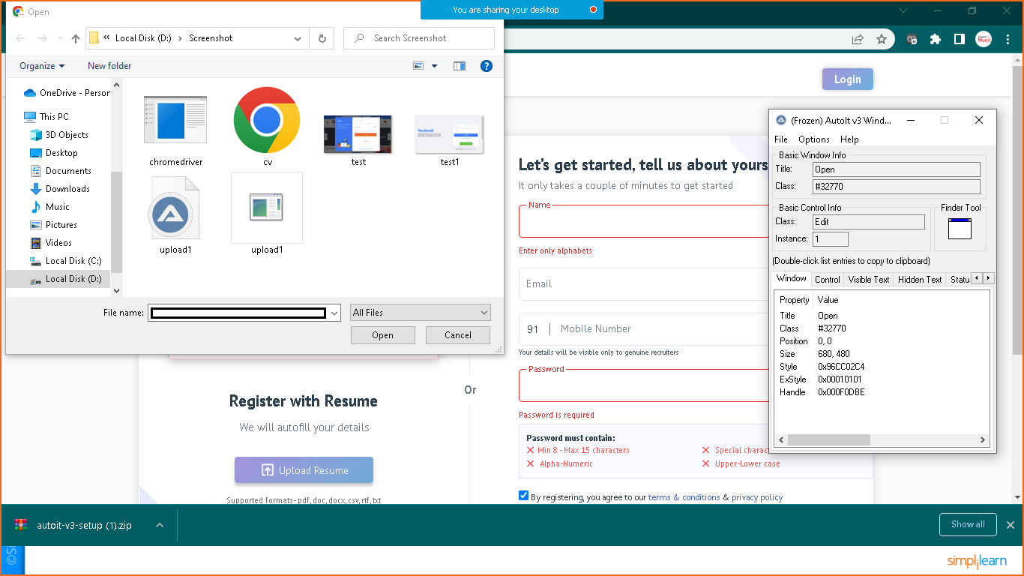

Now note down the Tittle , class and instace from finder tool

**Tittle: Open**

**Class: Edit**

**Instance: 1**

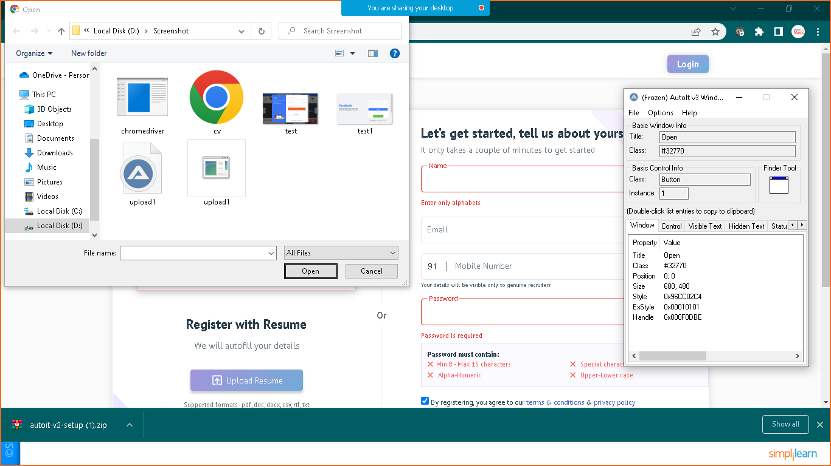

Now perform the same operation with Open Button and copy the same

**Tittle: Open**

**Class: Button**

**Instance: 1**

**Goto> C:\Program Files (x86)\AutoIt3\SciTE**

**Double click on SciTE and add the below script**

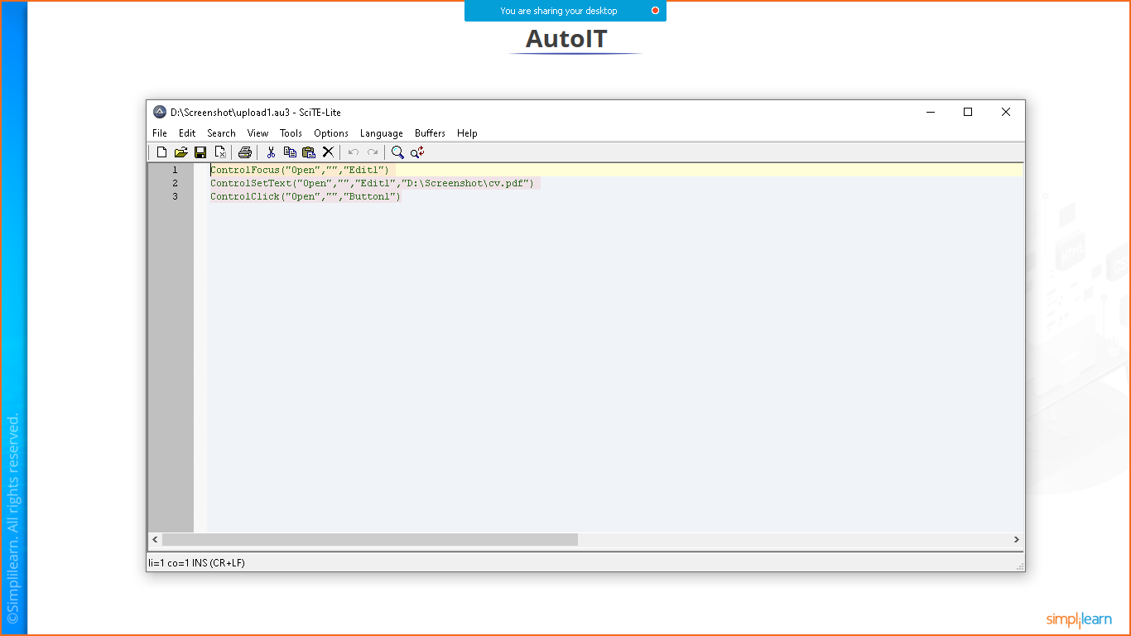

**//for selecting path button**

**ControlFocus("Open","","Edit1")**

**//choose a file from particular location**

**ControlSetText("Open","","Edit1","D:\Screenshot\cv.pdf")**

**//to open a file and upload it to the website**

**ControlClick("Open","","Button1")**

**Save it as**

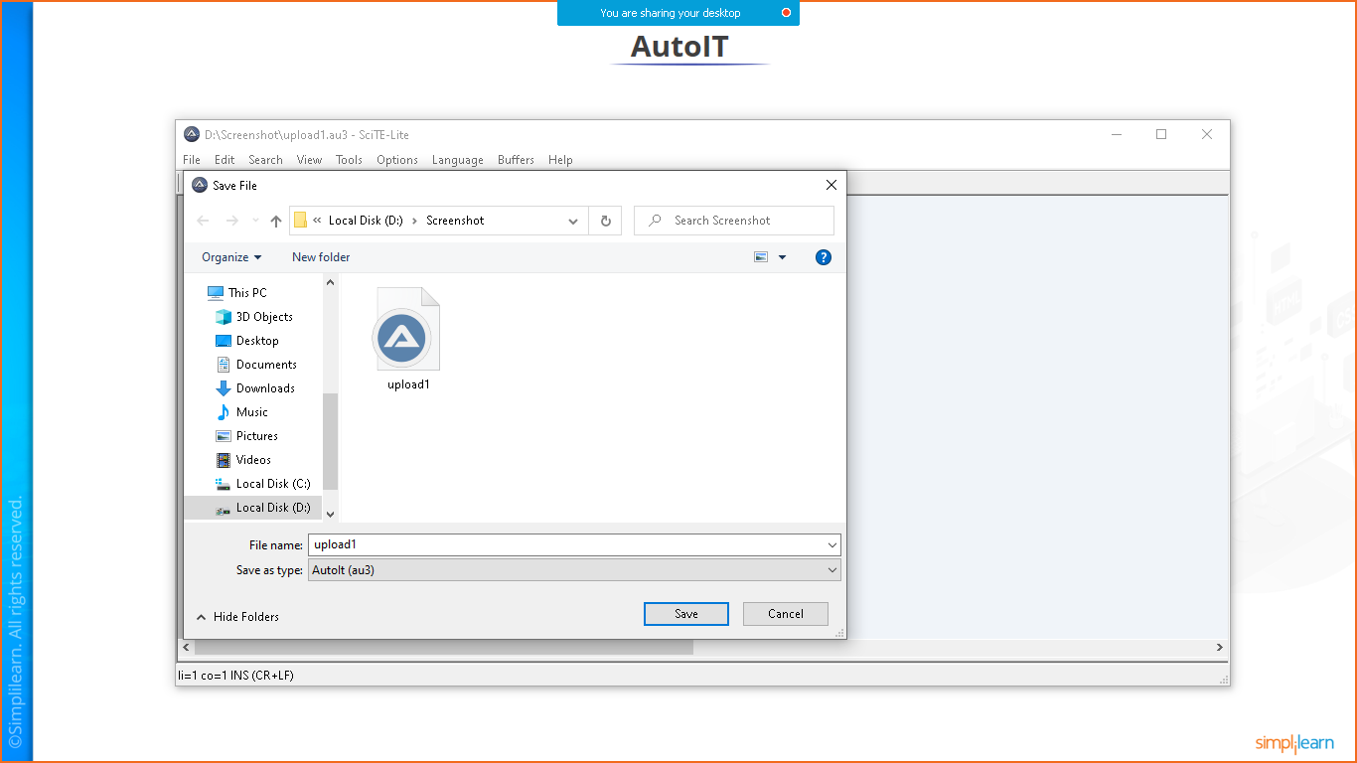

**Or you can directly save upload.au3**

Save it and go to the folder where you have saved the file

Now copy one pdf file named as cv.pdf

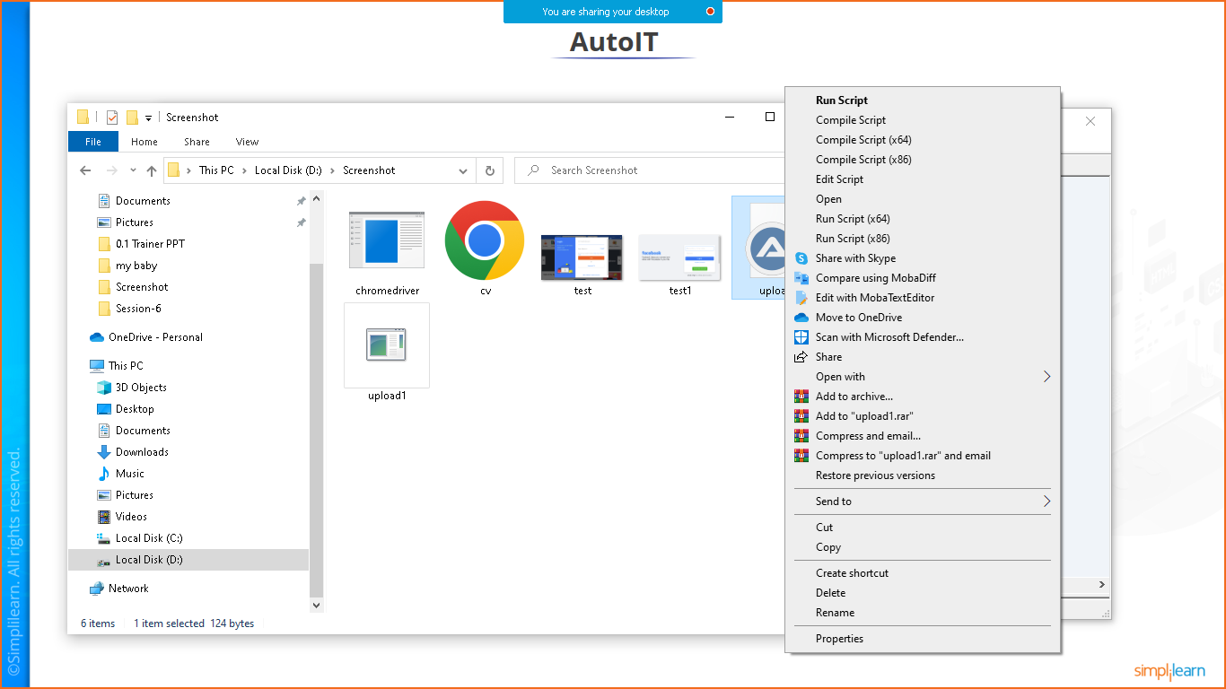

Right click on the file and compile the script as per your machine requirenment

Once the script will compile you will see **upload.exe** file is prepared automatically

Now open your eclips and prepare one java project and add the below code

**package** com.simplilearn.demo;

**import** java.io.IOException;

**import** org.openqa.selenium.By;

**import** org.openqa.selenium.JavascriptExecutor;

**import** org.openqa.selenium.WebDriver;

**import** org.openqa.selenium.WebElement;

**import** org.openqa.selenium.chrome.ChromeDriver;

**public** **class** AutoIt {

**public** **static** **void** main(String[] args) **throws** IOException,InterruptedException {

//assigning driver path

String Path= "D:\\Phase-5\\chromedriver_win32_latest\\chromedriver.exe";

System.*setProperty*("webdriver.chrome.driver", Path);

//initiate the driver

WebDriver driver= **new** ChromeDriver();

//giving Base Url

String base_url="https://www.shine.com/register/general/";

//launching in chrome

driver.get(base_url);

WebElement name= driver.findElement(By.*id*("id_name"));

name.sendKeys("Nikunj Soni");

WebElement email= driver.findElement(By.*id*("id_email"));

email.sendKeys("Nikunj@gmail.com");

///file upload

WebElement element= driver.findElement(By.*id*("id_file"));

JavascriptExecutor executor = (JavascriptExecutor)driver;

executor.executeScript("arguments[0].click()", element);

Thread.*sleep*(5000);

Runtime.*getRuntime*().exec("D:\\Screenshot\\upload1.exe");

}

}

Right click on it run as> javaapplication